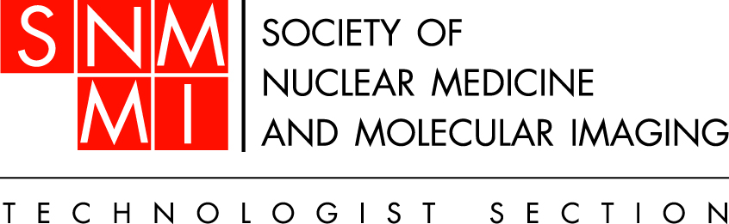

Committee Report
SNMMI-TS Executive Board

June 2013

Nuclear Medicine and molecular imaging Week Task Force

Committee Charges for 2012-2013
Goal B: Enhance Marketing
- Develop educational materials that outline the benefits of nuclear medicine and molecular imaging.
  - Create a task force focused on Nuclear Medicine Week.
  - Enhance the promotion and visibility of Nuclear Medicine Week.
  - Use NMW marketing to increase Public Awareness of nuclear medicine and molecular imaging
Goal G: Improve Resource Management
- Increase development of revenue-producing programs.
  - Have NCOR delegates provide input from chapters as to what the chapters would like to see offered.
  - Send more frequent emails about SNMTS items for sale, and include the less expensive items such as the pin or coffee cup to take advantage of impulse purchases.
  - Encourage Chapters to use NMW revenue-producing programs to increase local awareness of Public awareness of this industry
Other Charges (not specifically outlined in strategic plan)
- Develop Nuclear Medicine Week theme
- Work with SNM Marketing Staff to determine what product should be offered during NMW.

Current Objectives/Goals (please reference Strategic Plan):
- All products have been selected and are for sale at the SNMMI booth #1526 as well as on the SNMMI website
2013 product line
    - Poster
    - Pen
    - Lapel pin
    - Lanyard
    - Scientific calculator
    - Children’s t-shirts
    - Lunch bag
    - Mug
    - Soup bowl

- Marketing is currently working on the marketing plan that is scheduled to launch in July. It will consist of direct mail, email marketing and social media.

Progress of Charge/Objectives/Goals to Date:

Key Goals/Objectives for 2012-2013
Heighten Positive Awareness of Nuclear Medicine & Molecular Imaging

