**SNMMI-TS Membership Committee**

Conference Call

# September 23, 2014

# Minutes

**Member Participants:** Bryan Kerr, CNMT, PET, NCT, RT(N) (CT), Jocelyn Charest, Charlie Flores, CNMT, MBA, Anthony Knight, MBA, CNMT, RT(N), NCT, FSNMMI-TS, April Mann, MBA,CNMT,NCT,RT(N),FSNMMI-TS, Dean Rice, CNMT, PET, BS

**Members Not in Attendance:** Norman Bolus, MSPH, CNMT, FSNMMI-TS, Cynae Derose, CNMT, David Gilmore, MS, CNMT, RT(N), George Pluchino, CNMT, Aaron Scott, CNMT, NMAA, FSNMMI-TS, Deborah Wilkinson, MS, CNMT

**Staff in Attendance:** Joanna Spahr; Lauren Collins

1. **Welcome and Call to Order**

Bryan Kerr, MS, CNMT Membership Committee Chair called the conference call to order at 3:02pm. A quorum was not present.

1. **Membership Discussion**

April Mann, SNMMI-TS President joined the call to quickly review the charges and the new structure of the membership committee. She pointed out that from a leadership perspective what the committee really needs to focus on this year and to remind the committee what the charge and purpose of the committee is.

The SNMMI create a Task Force to look at membership strategically with 10 groups to focus on:

* Full Members
* Young Professionals
* ABNM Certified
* International
* Scientists
* Radiologists
* Annual Meeting Attendees
* Women in Nuclear Medicine
* Industry
* Cardiology

April discussed using the TS Membership Committee to tackle membership issues instead of creating another task force within the Technologist Section. She wants us to be looking at membership as a whole and determine what we need to do as far as membership going forward to be successful.

1. What can be done differently?
2. Who are our members?
3. Who do we want to be members?
4. What are our current member categories today? Do we need to include others?
5. Are there things we can be doing differently with the membership categories or other groups that could potentially be members of the Technologist Section?

**Ideas discussed:**

* Charlie Flores recommended that we our name change that we should continue to try to being in molecular imaging modalities such as Optical Imaging.
* Tony mentioned that we have credit tracking and that is a big benefit to a member.
* Joanna discussed with the committee that staff is seeing technologist members renewing every other year due to members needing credit over a 2-year period. The committee briefly discussed looking at a 2-year membership fee similar to what ASRT offers.
* International members represent 11.5% of the membership. With SNMMI representing 72% and 4% for Technologists (433 international Tech members).
* Hardship member option: loss of job or illness. Requirements would need to be met and could possibly be logistically difficult to track. Bryan mentioned that this was discussed in the past.
* Member-get-a-member program
* Hospital reimbursing dues
* Dues increments: is it possible to pay dues in increments during the year?
* Putting value on membership

1. **Membership Report**

Joanna reported that as of September 17th, 9,208 have renewed their membership and 274 have taken advantage of the in-transition bridge. In addition 1,484 students enrolled in the free trial program. The SNMMI-TS has not met budget this year. The shortfall is mainly with the in-transition and the Technologists upgrading from their transition year.

The 2015 renewal year launched for Technologist members on September 11th. Currently, to date 1217 members have renewed.

1. **Webinar Series**

April Mann, SNMMI-TS President thanked the committee for coming up with a new benefit for members. She discussed that now it is time to pass this off to the CE Committee to continue finding topics and speakers to continue implementing this benefit.

*Action: Joanna to follow up with staff that liaison with CE Committee*.

1. **SNMMI-TS Fellows**

Joanna reminded that group that the deadline for applications is November 1st. We have one application with another pending. Bryan mentioned that he would be applying as well as other colleagues of his.

1. **Facebook**

Bryan asked the group if anyone saw the recent Facebook post regarding the annual meeting and how he felt it had a negative impact on membership.

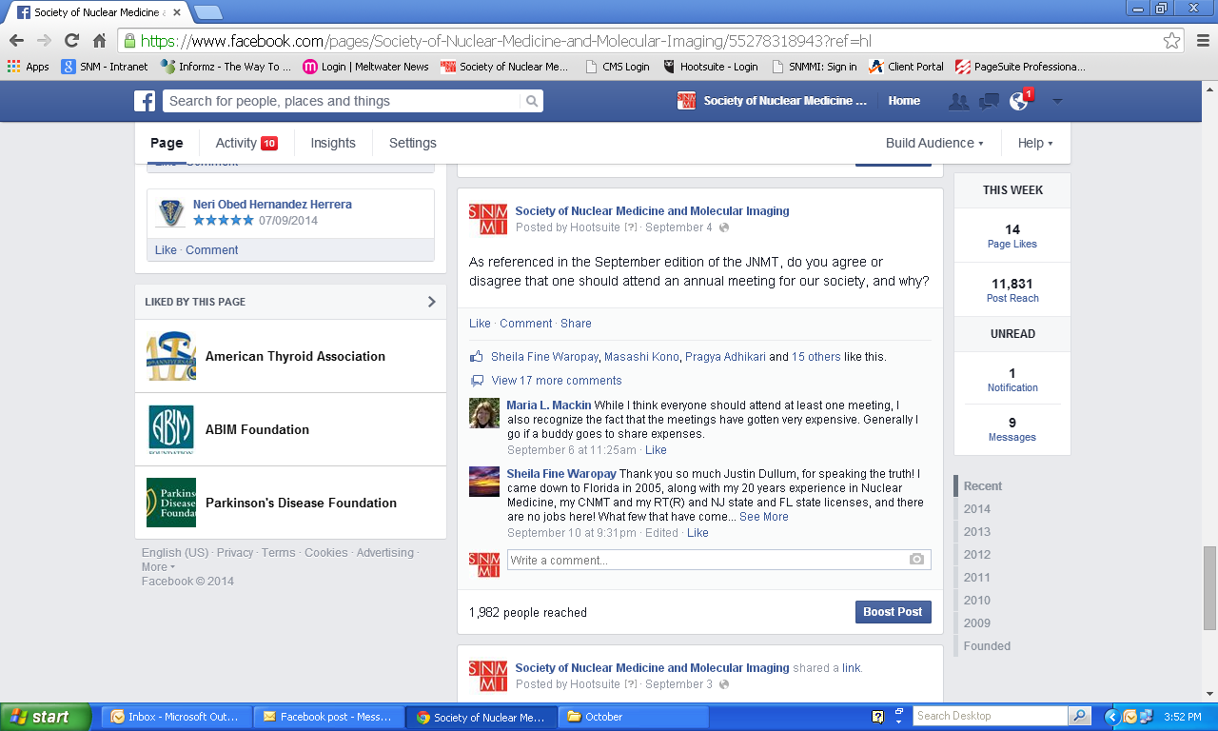

1. **LLSAP Modules**

Bryan Kerr, chair briefly discussed the LLSAP modules as a pick up item from the last committee. The committee was going to take a look at a list of all the old LLSAP modules to see if there were any that could be repurposed as a member benefit.

*Action: Joanna to send list to committee for review.*

1. **Adjournment**

The SNMMI-TS Membership Committee conference call adjourned at 3:53pm (ET).